Policy# 1344760 mod 25

Search for this policy in GW model and open mod 25

Select 'Change Summary' tab :-

**Expected-> Policy change summary should be populated**

**Actual-> System displays "No changes made to current policy".**

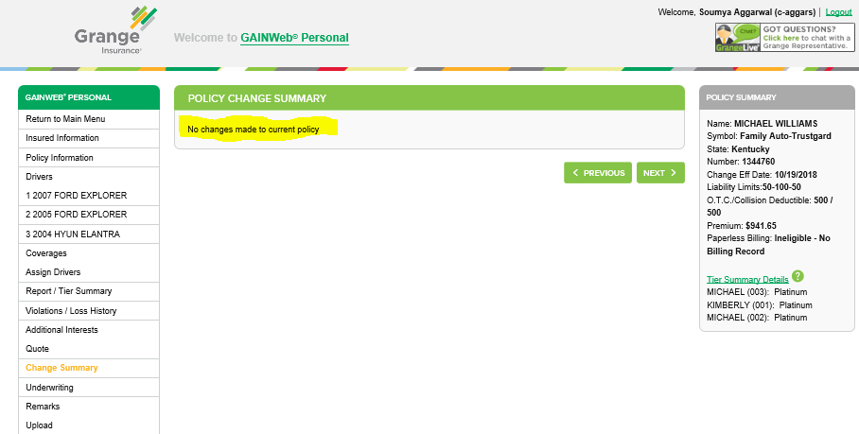

Now switch to any other tab, like, Drivers, Remarks etc, except Coverages

Switch back to Change summary -> Still no summary is populated, as unexpected

Now switch to **'Coverages'** tab

Switch back to 'Change Summary' tab

This time, finally, user can see the Policy change summary details, which was expected even in the above mentioned steps

